**ECSE 428 – Assignment D**

**Setup Instruction**

Jun Young Shin

260499663

March 26, 2018

This document will explain the setup process need it to install visual studio, load the code, and instruction to run the code.

# Installing Visual Studio (Mac)

The Visual Studio Community Edition can be download through the Microsoft web through the link <https://www.visualstudio.com/downloads/>. This demonstrates the installation process for the version 2017 for Mac.

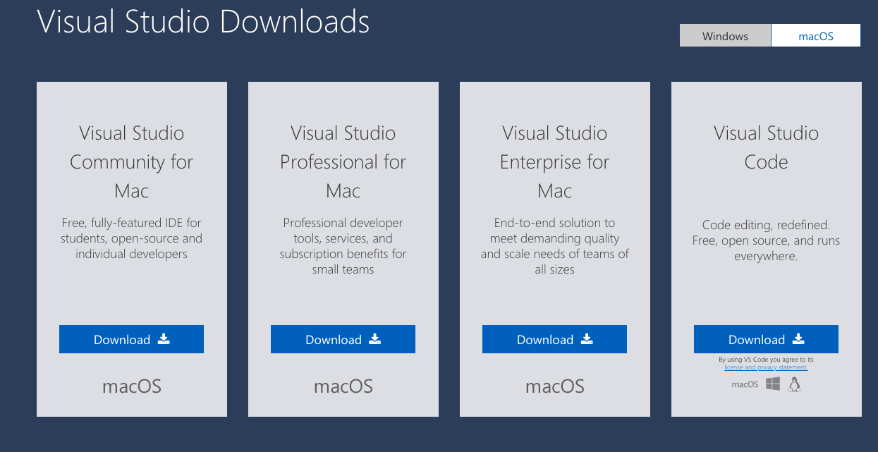

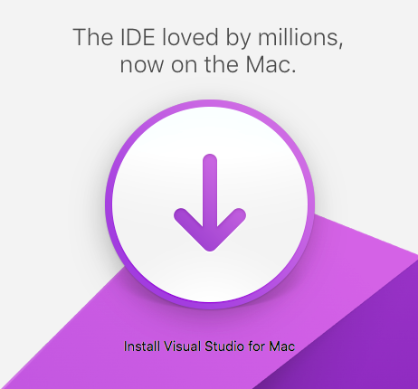

Click on the *Download* button to start downloading the installation .dmg. After successfully downloading the .dmg, start the installation process by selecting the program by going to the folder in which the program is downloaded.

Click on the Install Visual Studio for Mac icon to start the installation. Follow the instruction to install Visual Studio Community edition for Mac.

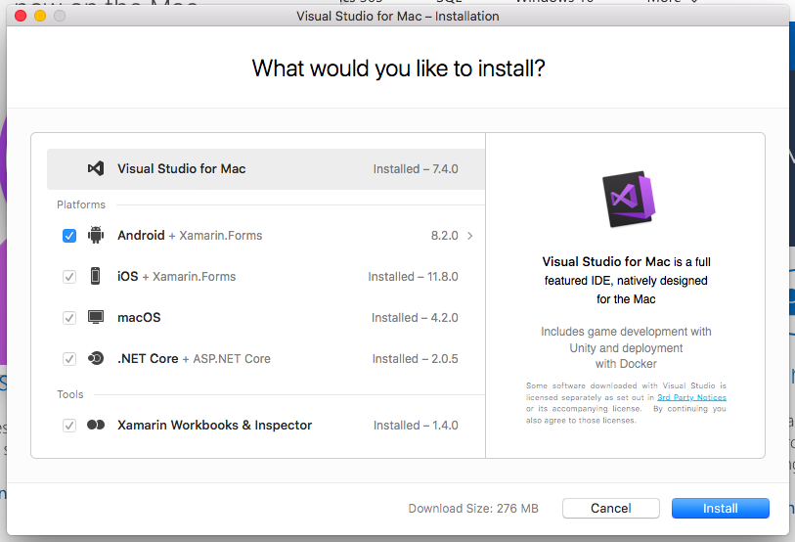

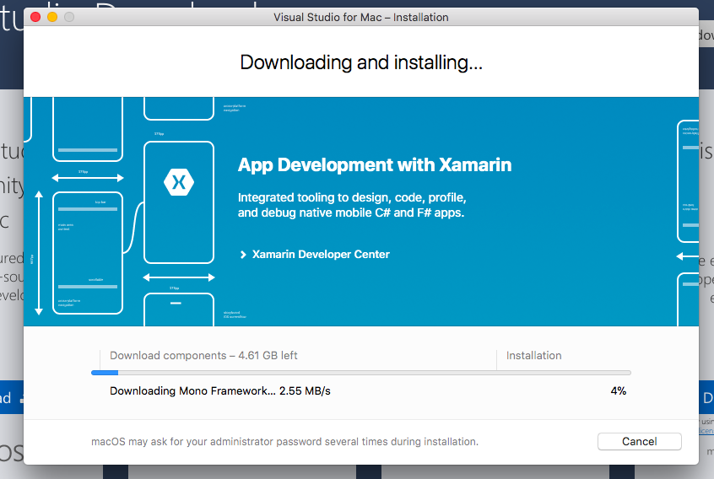

During the installation process, it will ask for authorization from the user. As such, please login using your computer user name and password.

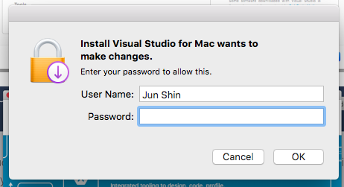

When everything is installed correctly the message will prompt and you may start using Visual Studio Community edition.

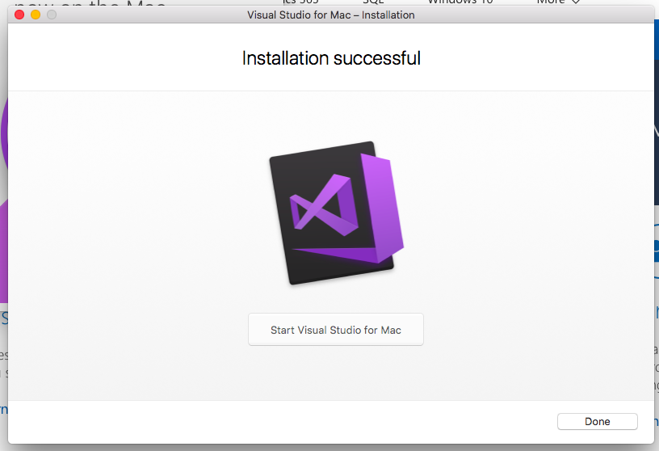

# Loading code into Visual Studio (Mac)

# Running the code (Mac)